HFA Android App

USER’S MANUAL

Authors:
Joshua Reisenauer - jar055100@utdallas.edu
Muhammad Khan – mik016000@utdallas.edu
Jerry Arnold - jxa074000@utdallas.edu
Binh Vu - bnv061000@utdallas.edu

Students ECS 4485.502

November 20, 2010
Revision Sheet

Release No. | Date | Revision Description
1.0 | 11/20/2010 | Initial Revision

USER'S MANUAL
Table of Contents
1.0 GENERAL INFORMATION 1
1.1 System Overview 1
1.2 Authorized Use Permission 1
1.3 Points of Contact 1
1.3.1 Information 2
2.0 SYSTEM SUMMARY 2
2.1 System Configuration 3
3.0 Step by Step Tutorial 4
4.0 Support Information 15
5.0 Appendix 15

GENERAL INFORMATION
This document provides the overview, contact information, and step by step tutorial of the HFA application.

1.1 System Overview

The characteristic challenges and opportunities of mobile services design have recently led software designers to develop wide variety of mobile apps that leverage the user needs of many small to mid-range markets, as evidenced by many white papers.

HFA comes as one of the few Android mobile apps in patient centric healthcare industry. HFA provides a valuable access interface to OpenEMR system (a small to mid-size clinical and financial management system) for Android Market. OpenEMR is the 130,000 download strong user’s community; HFA Android app interface brings a breeze for clinician users of OpenEMR system.

HFA application is intended to assist with data retrieval services from OpenEMR for quick clinical evaluations. HFA controls different levels of users, parsing the terms and prompting the clinician for any abnormalities. Encrypted communication of HFA with OpenEMR database contents provides a quick, easy, and reliable access for fast clinical decision making process. HFA is an instance based healthcare Android app with navigational queues that renders the secure data calls in compliance with HIPAA and assist clinicians for quick, easy, and reliable patient’s data management.

The HFA app delivers database information, parse incoming data streams, and produce a quick view of some key areas of OpenEMR system.

1.2 Authorized Use Permission

Usage of this app is limited to its owner practice/facility via the terms of its development. HFA can be only used as explained under the terms of the agreement. HFA development team has all the ownership rights reserved for this app and its future versions. HFA development team includes Jerry Arnold, Binh Vu, Muhammad Khan and Joshua Reisenauer. HFA may not be used or referenced without proper consent of development team.

1.3 Points of Contact
Binh Vu - bnv061000@utdallas.edu
Jerry Arnold - jxa074000@utdallas.edu
Joshua Reisenauer - jar055100@utdallas.edu
Muhammad Khan – mik016000@utdallas.edu

1.3.1 Information
For any further inquiries related to HFA app, please contact the above referenced email addresses in points of contact.

SYSTEM SUMMARY
HFA application is intended to assist with data retrieval services from OpenEMR for quick clinical evaluations. HFA controls different levels of users, parsing the terms and prompting the clinician for any abnormalities. Encrypted communication of HFA with OpenEMR database contents provides a quick, easy, and reliable access for fast clinical decision making process. HFA is an instance based healthcare Android app with navigational queues that renders the secure data calls in compliance with HIPAA and assist clinicians for quick, easy, and reliable patient’s data management.

2.1 System Configuration

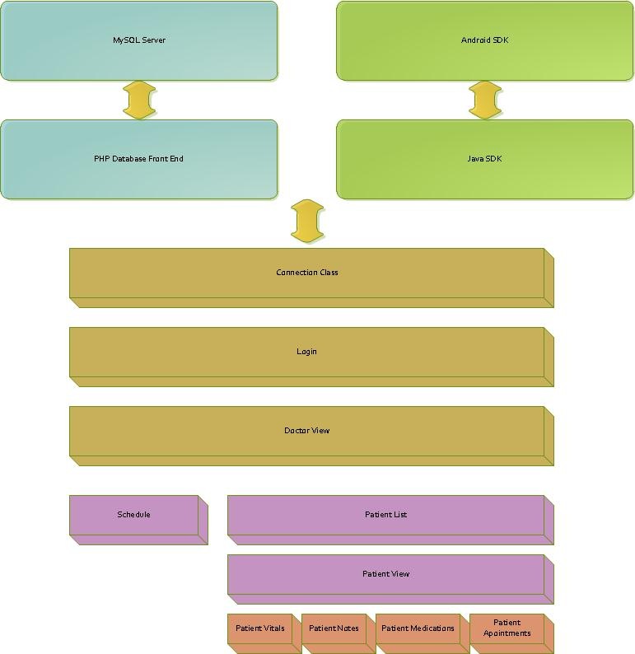

The system is connected via a 3G or a Wi-Fi connection. Since, data calls that send/receive data entirely connects within a predefined OpenEMR system, HFA provides a quick, easy, and reliable Android interface of the data that contains some limited functionality. Local fields, variables, and other data sources are initialized by the system during startup, and then updates and populate relevant information from web queries of the OpenEMR system.

Step by Step Tutorial
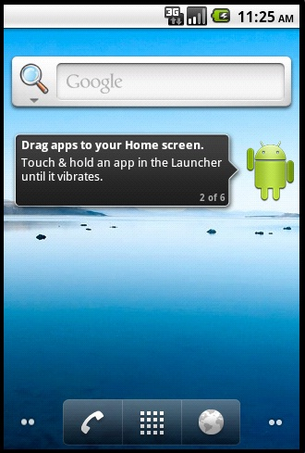

-When Main Menu is loaded click on the middle button on the lower portion of the screen. This will load up the app listing page.
-When app listing page has loaded it should have a little icon in the list named health foundation with a red cross on it. Click this icon, it will load health foundation.
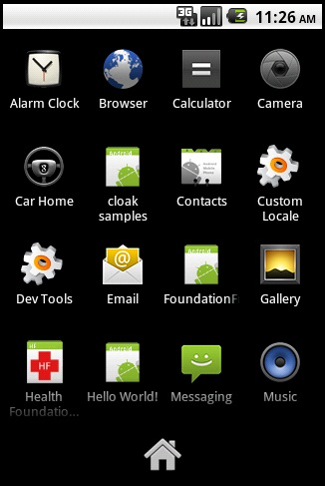

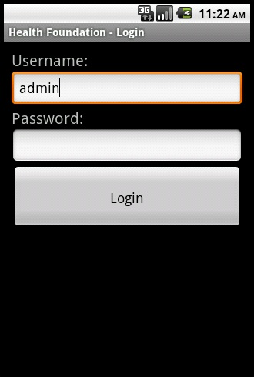

-When health foundation has loaded the menu similar to the one above will appear. Enter your user name and password and click login. If you do not currently have an account set one up through the database website. When you log in it will automatically move you into the Doctor menu.

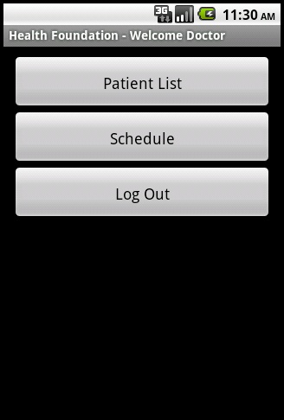
-The doctor menu will look like the one above. Clicking on patient list will show you a listing of all patients including the patients of other doctors in your database. Clicking schedule will open a menu allowing you to create/edit/delete calendar entries. When done using health foundation always make sure to return to the doctor menu and click log out.

-Patient list menu will look like the above picture. Moving your finger across the screen vertically will scroll the list entries. Selecting a name in the list will open the patient menu for that particular person.
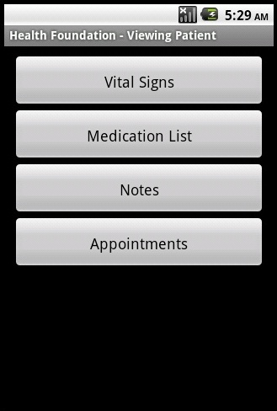

-For the patient menu. Clicking vital signs will display patients temperature, code, body mass index and date it was taken. Medication List will display Drug name dosage, units, and current prescription status. Notes are for notes about this patient which can be viewed by all other doctors of this patient. Appointments will display a list of appointments this patient is scheduled for.

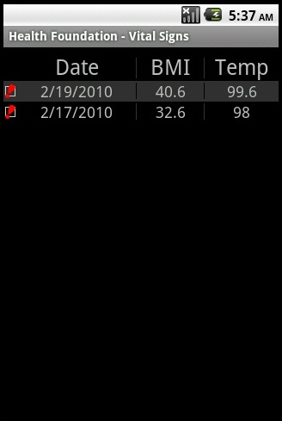

-The vitals menu will display individual vital sign measurements, sorting date in descending order by default.

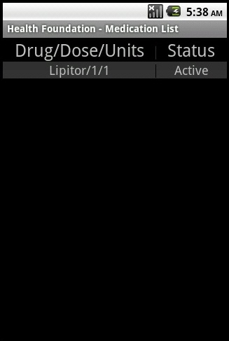

-For medications menu, Status/Drug/Dose/Units are displayed. Active medications are listed first.

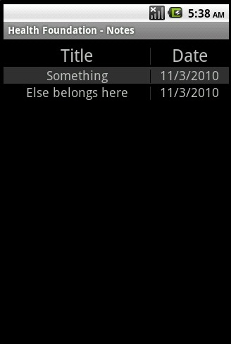

-Patient notes menu above will display all notes made by doctors for this patient. All notes are sorted by date by default. To add a note go to the off screen menu interface to click add. To edit or delete simply click on one of the notes.



-When a note is clicked it might just look like the one above. Clicking save will update the note to the database.

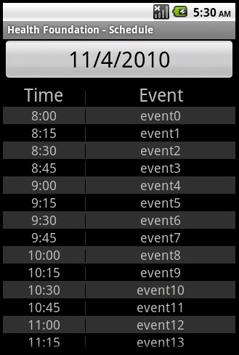

-The schedule in the doctors menu will look like the picture above. Listed by time by default, to add a new schedule entry click the big button with today's date listed on it. To modify or delete a previous entry simply click on one of the entries.

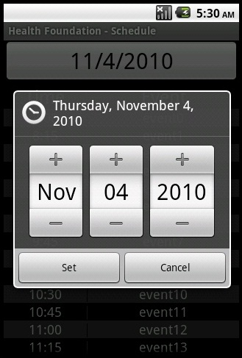

-When you clicked on the big button from the previous page it will load a calendar cog like the one above. Choose the approximate date for an upcoming event and click set. This will generate a hollow event entry now another menu will pop up asking for an event description.

Support Information
For any support information, please contact any of the team members

Joshua Reisenauer - jar055100@utdallas.edu
Muhammad Khan – mik016000@utdallas.edu
Jerry Arnold - jxa074000@utdallas.edu
Binh Vu - bnv061000@utdallas.edu

Students ECS 4485.502

Appendix
Further resources regarding the Android apps development and more about electronic medical records, and HIPAA can be found here:
- Android application development http://developer.android.com/index.html
- Google Healthcare http://www.google.com/health
- OpenEMR http://www.oemr.org
- HIPAA - http://www.hhs.gov/policies/index.html
- US government site that provides up-to-date healthcare reform news http://www.healthreform.gov

